Choice of parameter for SNF 0M8 model

Maximum Kd calculated from the optimization with a constraint that Km>Kd

Kd = 0.5925671

At = 2.9925    alpha = 2.9935    Vmax=1.3010    Km=1.0043

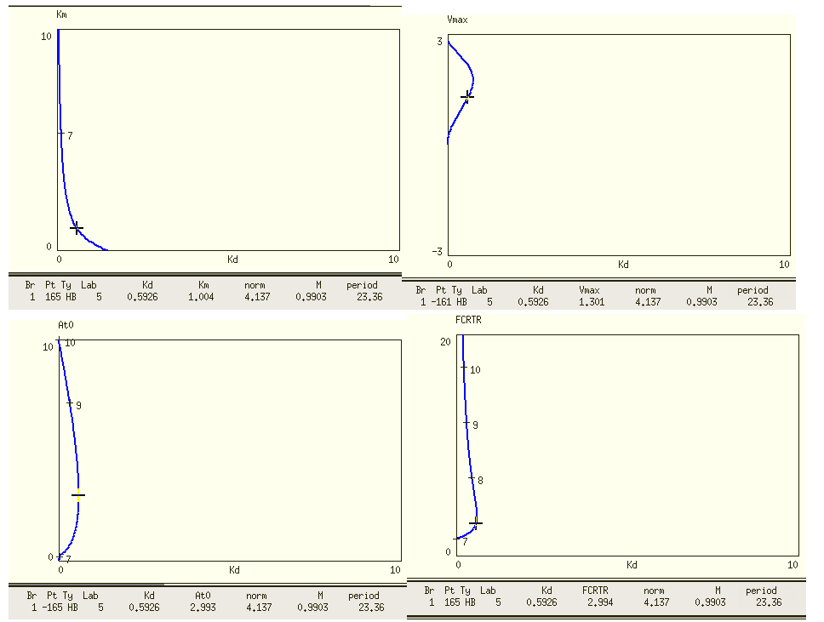

If choose Kd = 0.3, At0-alpha 2D bifurcation curve is shown below.

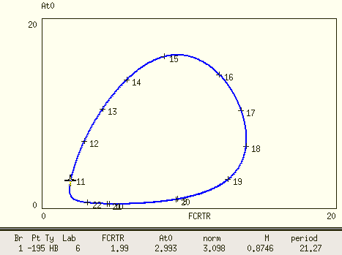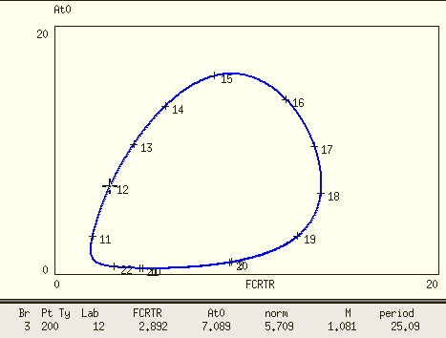

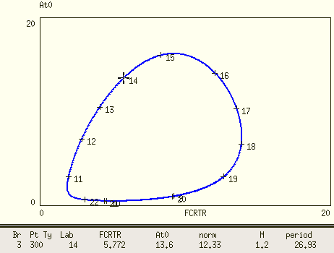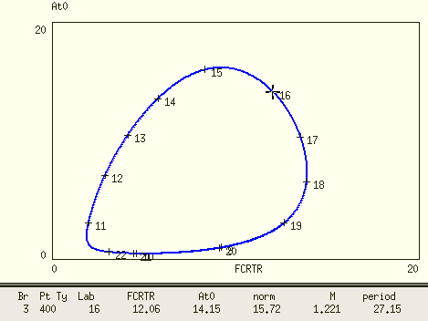

Based on these 4 points, I choose At0 = 6, FCRTR=6

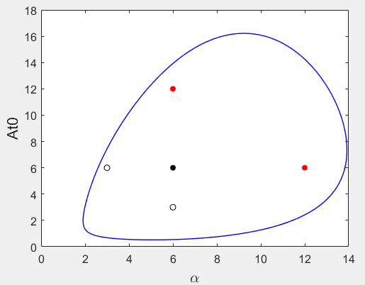

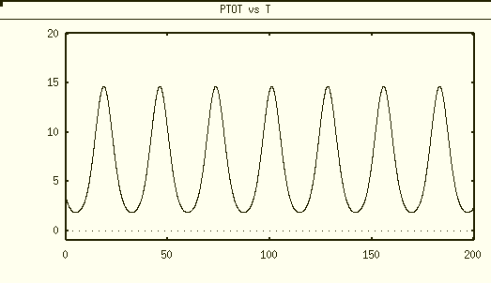

Ptot = 15

P* should be around 100nM/Ptot^_max

P* = 6.67 nM

Dimensional Kd ~ 0.3*6.67 = 2